Hall Effect

**Experiment No.: __________ Date: __________________**

**Aim:**

To study Hall Effect

**Apparatus:**

1. Electromagnet
2. Constant current power supply
3. Hall probe
4. Gauss meter
5. Hall effect set-up

**Theory:**

When a current carrying conductor (or semiconductor) is placed in an external magnetic field perpendicular to the direction of current, a voltage is set up in a direction perpendicular to both current and magnetic field. This is known as Hall Effect.

If a semiconductor has the dimension in x, y & z,

The current density J is along X –axis,

The magnetic field H is along Z – axis,

The electric field E will be set up along Y – axis

Where the Hall co-efficient

$R_{H}=\frac{{(V_{H})}_{Y}/Y}{J_{x}H_{z}}=\frac{{(V_{H})}_{Y}Z}{I_{z}H_{Z}}$----------------------------- (1)

Where ${(V_{H})}_{Y}$ is the Hall voltage appearing along Y – direction.

From the consideration of Lorentz force experienced by the carriers, we can also show

$$R_{H}=\frac{1}{nq}$$

------------------------------------------------- (2)

Where $n =$ carrier concentration

$q=$ Charge of carrier

**Procedure:**

1. The constant current power supply was connected to the electromagnet, to set up a desired value of magnetic field, by allowing current to flow through the coils of either pole.
2. The value of the magnetic field intensity thus set up can be measured by the digital gauss meter supplied. This value in gauss is noted down and kept fixed.
3. The hall probe connection is made i.e. the width wise connection to the terminal marked ‘voltage’ (red wires) and length wise connection to the terminal marked ‘current’ (green wires) in the Hall Effect set up.
4. Hall Effect set up is switched on and current flow through the Hall probe is adjusted in mA unit.
5. By switching over to the voltage display the corresponding Hall Voltage is measured. If there is some reading even outside the magnetic field, it should be adjusted to the minimum possible value. This can be taken as the error and has to be subtracted every time.
6. The Hall probe is placed on its carrying stand in between the two poles of the electromagnet. The Hall probe is rotated in the field till it becomes perpendicular to the magnetic field. Hall voltage will be maximum in this adjustment.
7. In the constant magnetic field, the Hall voltage as a function of current is taken several times and a graph is plotted.

**Precautions:**

1. While making connections all the power supply should be switched off.
2. To avoid heating, there should be proper ventilation.
3. The poles are to be covered with grease to avoid rusting, etc.

**Observation:**

**Table -1** **Table - 2**

${ H}_{Z_{1}}$ = _________ Gauss $H_{Z_{2}}$ = ________ Gauss

|  |  |  |  |  |  |  |
| --- | --- | --- | --- | --- | --- | --- |
| Sl. No. | (*IX*)  Hall current  in mA | (*VY*)  Hall Voltage in mV |  | Sl. No. | (*IX*)  Hall current  in mA | (*VY*)  Hall Voltage in mV |
| 1 |  |  | 1 |  |  |
| 2 |  |  | 2 |  |  |
| 3 |  |  | 3 |  |  |
| 4 |  |  | 4 |  |  |
| 5 |  |  | 5 |  |  |
| 6 |  |  | 6 |  |  |
| 7 |  |  | 7 |  |  |
| 8 |  |  | 8 |  |  |
| 9 |  |  | 9 |  |  |
| 10 |  |  | 10 |  |  |

**Graph:**

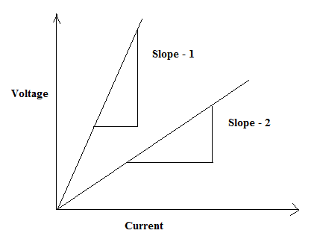

**Calculation:**

Z = Thickness of the specimen = 0.05 cm

Slope – 1 = $\frac{V_{Y}}{I_{X}}=$

Slope – 2 = $\frac{V_{Y}}{I_{X}}=$

$$R_{H_{1}}=\frac{Z}{H_{Z_{1}}}\left(Slope-1\right)=$$

$$R_{H_{2}}=\frac{Z}{H_{Z_{2}}}\left(Slope-2\right)=$$

Therefore, $R_{H}=\frac{R_{H_{1}}+R_{H_{2}}}{2}=$

**Conclusion:**

**Marks Awarded**

|  |  |  |  |
| --- | --- | --- | --- |
| Planning and Execution  (2) | Result and Report  (6) | Viva  (2) | Total  (10) |
|  |  |  |  |

Signature of the student:

Regd No:

Group:

Branch:

Signature of the faculty